DTSC 671: AI Solutions in the Cloud

SUBMISSION TEMPLATE:
Speech-to-Text with Amazon Transcribe

Select File > Make a copy to edit the template and add your screenshots. Download the completed template as a PDF document to submit to Brightspace.

In every screenshot, include your AWS username that appears in the upper right corner. Example:

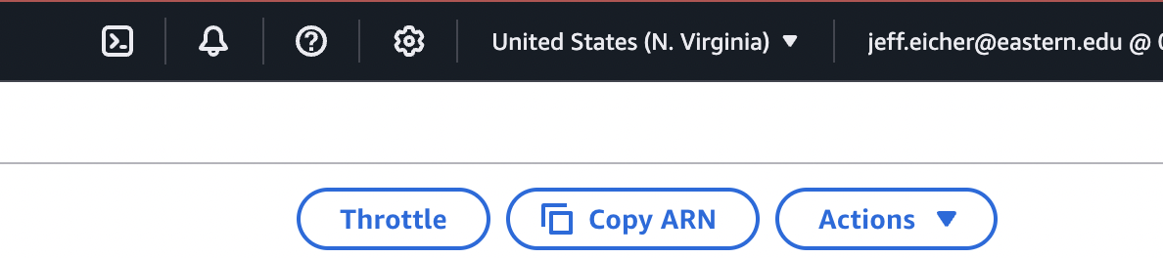

If any one screenshot is missing this identification, the entire assignment will be scored no higher than 70%.

Points totals are provided at the start of each question. You score either full credit or 0 points; there is no partial credit for each question.

- [10 points] In the space below, provide a screenshot of the Lambda function #1 diagram (with trigger and destination).

- [10 points] In the space below, provide both a screenshot of the beginning of your Lambda code with your account showing, then copy-paste your full lambda code below the screenshot.

- [10 points] In the space below, provide a screenshot of three buckets: one input, one output-JSON, one output-TXT. You can search by “transcribe” to have only the transcribe buckets in the list.

- [10 points] In the space below, provide a screenshot of the CloudWatch log streams for your Lambda function #1. Fit as many as you can in the screenshot.

- [10 points] In the space below, provide a screenshot of the CloudWatch stream that functioned without errors for Lambda function #1.

- [10 points] In the space below, provide a screenshot of IAM role permissions for the second Lambda function: JSON-to-TXT.

- [10 points] In the space below, provide a screenshot of the JSON file output—not the file sitting in an S3 bucket but the actual output. (Your username does not need to appear in this screenshot.)

- [15 points] In the space below, provide a screenshot of the TXT file output, that is, I want to read the transcription and see how it compares with what you said in the video. (Your username does not need to appear in this screenshot.)

- [15 points] You will upload your video MP4 to Brightspace separately.

